Year 12 Acid and Bases

Question 1
(1 mark)

HSO₄⁻ (aq) + H₂O(l) <===> H₃O⁺ (aq) + SO₄²⁻ (aq)

In the equilibrium represented above, the species that act as bases include which of the following?

I. HSO₄¯
II. H₂O
III. SO₄²¯

(A) II only
(B) III only
(C) I and II
(D) I and III
(E) II and III

Question 2
(1 mark)
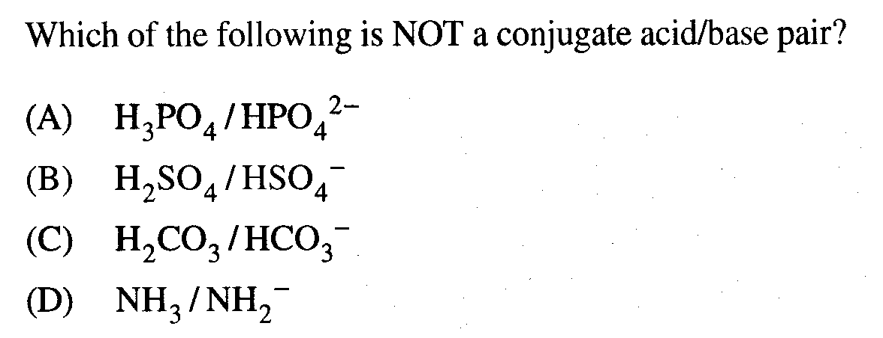

Question 3
(1 mark)

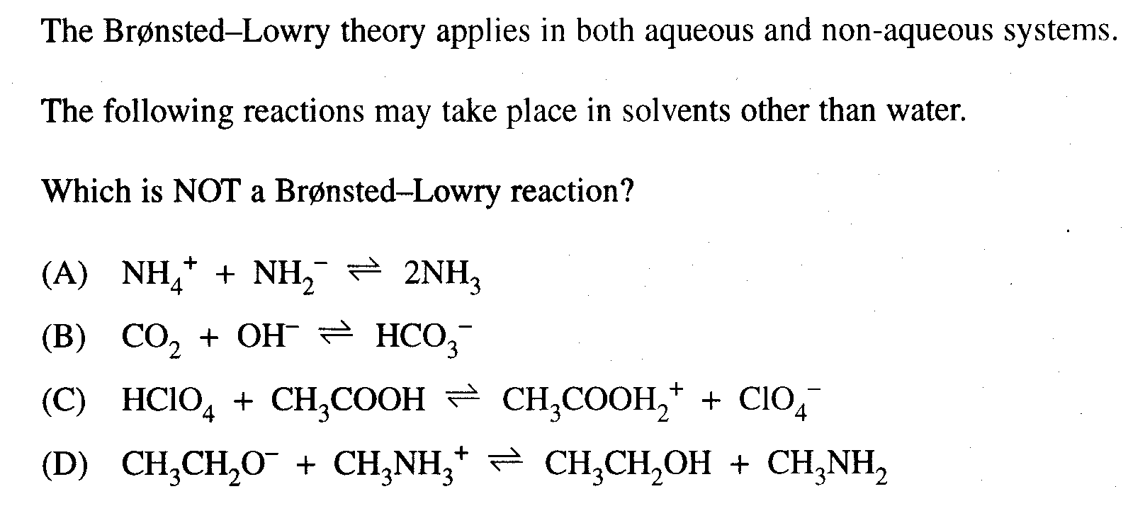

Question 4

Define each of the following giving a real chemical equation to illustrate your definition.

(a) An Arrhenius base.
(2 marks)

________________________________________________________________________

________________________________________________________________________

________________________________________________________________________

________________________________________________________________________

(b) A Brønsted-Lowry base. (2 marks)

________________________________________________________________________

________________________________________________________________________

________________________________________________________________________

________________________________________________________________________

Question 5

(a) Is acetic acid a non-electrolyte, a weak electrolyte or a strong electrolyte? Why?

(2 marks)

________________________________________________________________________

________________________________________________________________________

________________________________________________________________________

(b) Is water a non-electrolyte, a weak electrolyte or a strong electrolyte? Why?

(2 marks)

________________________________________________________________________

Question 6

It is suggested that SO₂ which contributes to acid rain, could be removed from a stream of waste gases by bubbling the gases through 0.25 M KOH, thereby producing K₂SO₃. Calculate the maximum mass of SO₂ that could be removed by 1000 L of the KOH solution?
(5 marks)

Question 7

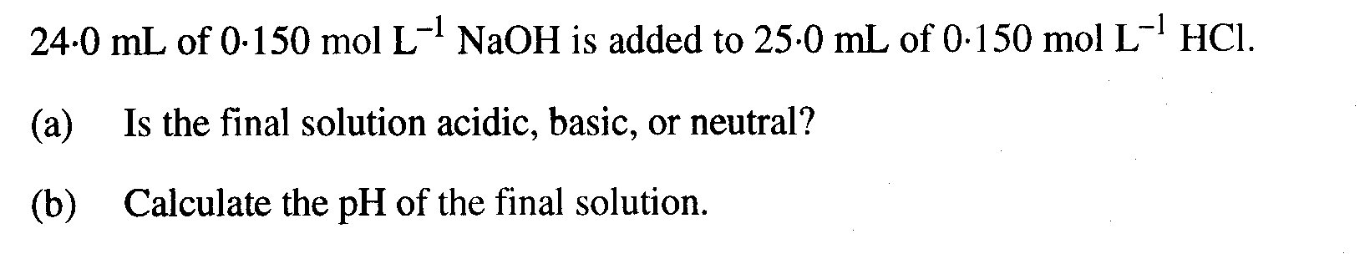
(7 marks)

Question 8

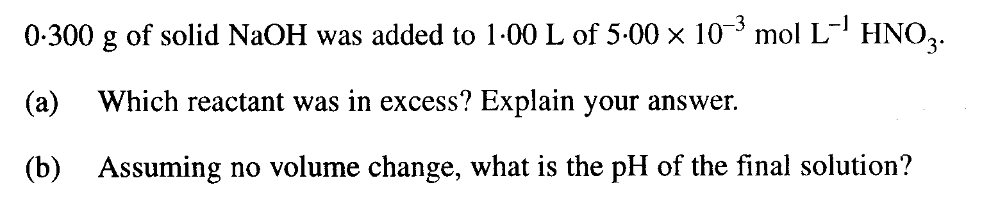
(5 marks)

(3 marks)

